Simulation study protocol – Breakpoints’ distribution
This document aims at explaining preliminary choices of breakpoints in the simulation study.
See R script at /github/mixedBreak/test/distrib-breaks.R
One of the main goals of the simulation study is to generate fictive patients to benefit from having a large amount of data for model evaluation. But most importantly, we need to generate patient that looks like real patients, up to a certain noise level that we can control.
A modelling choice was made based the characteristic reported in Stenbæck et al. (https://journals.sagepub.com/doi/10.1177/0269881120959609). By reproducing the analysis described in this article, we can then base the simulation means and noise level on the following results (mean (sd) [range] in minutes after drug intake):
- Breakpoint 1: 77.2 (38.2) [32.5 ; 157.9]
- Breakpoint 2 – breakpoint 1: 77.5 (33.3) [29.0 ; 142.8]
- Breakpoint 3 – breakpoint 2: 131.6 (39.3) [90.0 ; 204.1]
Modelling distance with a lognormal distribution allow to avoid using rejection sampling. The major drawback is that since breakpoint time-coordinates are simulated independently, the variance stacks up, resulting in higher time variability in later breakpoints:
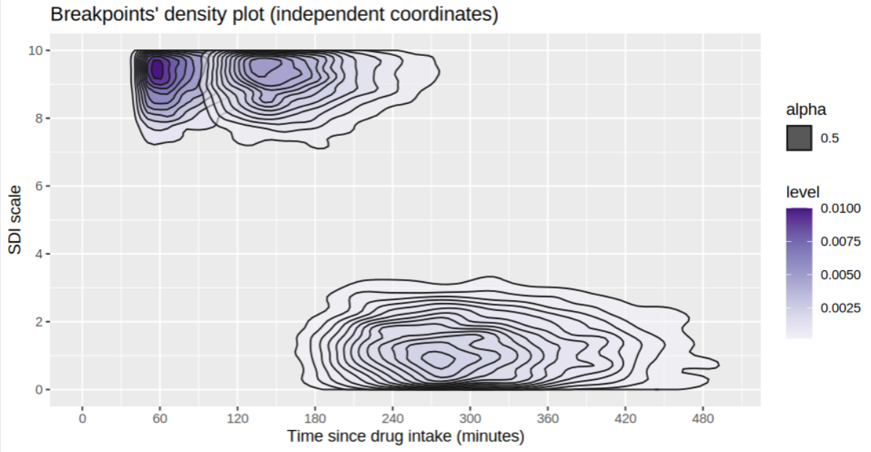
Figure 1 - Breakpoints density plot (n=5000)
It is not much desirable from a simulation perspective, since we then don’t control the time-variability of all breakpoints but the first one.
Correlating breakpoints’ coordinates for controlling ratio
Parameters of clinical interest are the onset slope, the duration of plateau, the return to normal consciousness slope, so one might consider simulating based on their distribution, instead of the breakpoints that have a less direct interpretation.
If simulating the slopes coefficients directly is possible, though it raises some issues due to the limited range of the SDI scale (0-10). Considering the bounds of SDI scale, it is mostly desirable to simulate breakpoints instead of slopes.
However, the slopes are the ratio of the y/x coordinates of breakpoints, so we don’t know the exact distribution of this quantity. On idea is drawing x and y jointly through a multivariate normal law. With a proper correlation specification, we could set up at least the average value of the ratio:
Intuitively, the correlation “shifts” the density ellipse of the multivariate normal distribution. If we can find a correlation value that shifts the ellipse so its semi-major axis is aligned with the line of directing coefficient $β_{onset}$, then we control the first moments of ratio $\frac{y}{x}$. In practice we have $σ_{X}≫σ_{Y}$ so we prefer to align the semi-major axis to induce lower ratio variance.
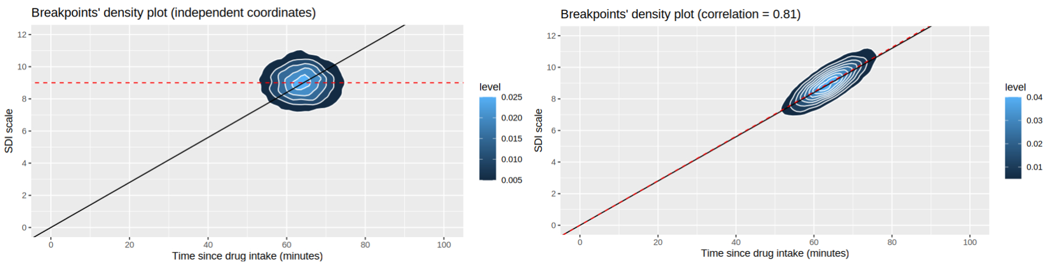
Figure 2 - (x,y) multivariate normal distribution with means = (63.9,9), sd=(sqrt(33),1) and rho = 0 (left) and 0.81 (right). Black line is the target with coefficient beta_onset, and red line is the BLUP of y given x and rho. N = 10 000.
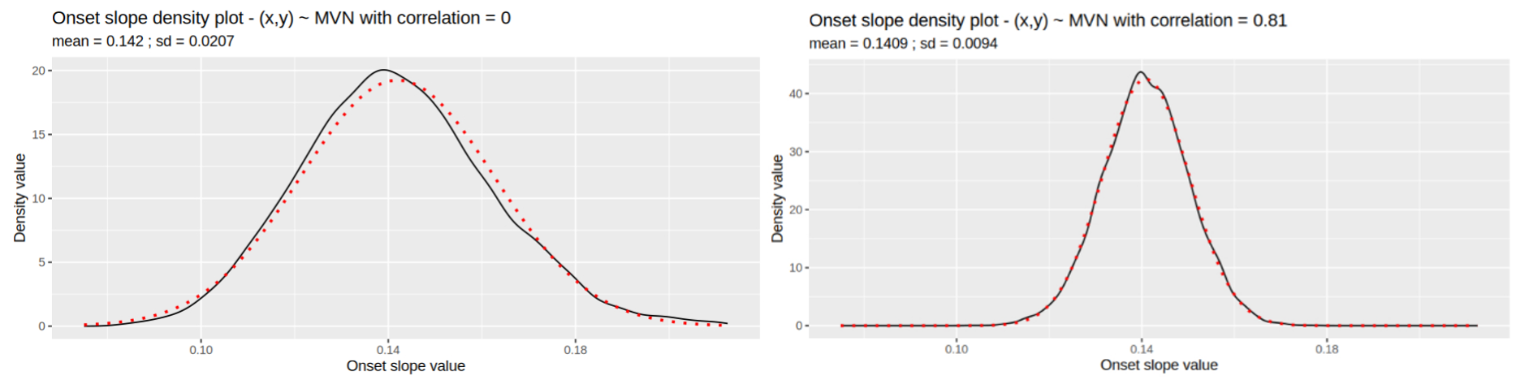
Figure 3 - Empirical distribution of ratio y/x. In red is the density of normal law with mean = mean(y/x) and sd = sd(y/x). N = 10 000
Simulation to check if mean ratio is on target?
Formally, let $\left(x,y\right)\sim N(μ,Σ^{2})$ be a random 2d real vector, with $μ=(μ_{X},μ_{Y})$ the vector of means and $Σ^{2}=\left(\begin{matrix}σ_{X}^{2} & ρσ_{X}σ_{Y} \\ ρσ_{X}σ_{Y} & σ_{Y}^{2}\end{matrix}\right)$ the variance-covariance matrix, with $ρ∈[-1,1]$ the correlation between x and y. For a given correlation $ρ$ and x value, we know the Best Linear Unbiased Predictor (BLUP) of y is:
$$y\left(x\right)=ρ\frac{σ_{Y}}{σ_{X}}\left(x-μ_{X}\right)+μ_{Y}$$
We can adjust the correlation coefficient accordingly so that $ρ\frac{σ_{Y}}{σ_{X}}=β_{onset}$. This way the ratio $\frac{y}{x}$ (of breakpoint coordinate) would average the desired value. However, the correlation coefficient $ρ$ is bounded, so it yields the following condition on the ratio of individual standard deviations:
$$-1<ρ<1⇔ -\frac{σ_{Y}}{σ_{X}}<β_{onset}<\frac{σ_{Y}}{σ_{X}}⇔|β_{onset}|<\frac{σ_{Y}}{σ_{X}}$$
In practice, we observed $β_{onset}=0.14±0.03, σ_{X}=33$ and $σ_{Y}=1$ which gives the ratio value $\frac{σ_{Y}}{σ_{X}}=\frac{1}{33}≈0.03<0.14=β_{onset}$ so the strategy is not applicable is this set up. At “best” we can set $ρ=1$ since the correct value would then be 4.65, yielding in the following distribution:
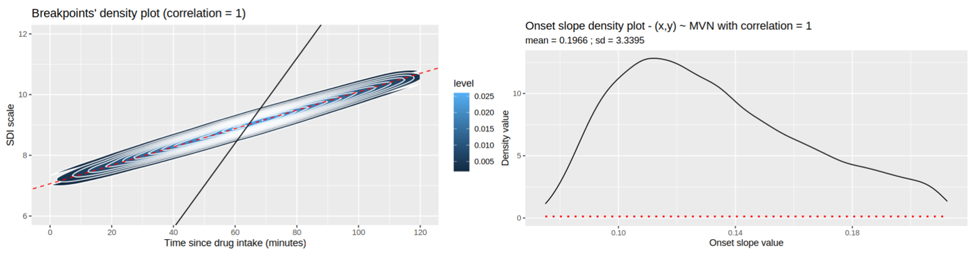
Figure 4 - (x, y) multivariate distribution with correlation rho=1 (left). Empirical density plot of ratio y/x (right). N=10 000
In this out of bound setup, one can see it “biases” the average ratio y/x, and induces a much larger variance. Hence the invalidity of this setup when the condition on ratio of standard deviation is not met.

Question: Is there any for rho such that we can control the mean and/or sd of the ratio y/x? In which setups, realistic or not?

